1. What are three conclusions we can make about Kickstarter campaigns given the provided data?

* The project types such as Theater, Film & Video, and Music that fall into the category of “Entertainment” seems to be the most common project types with the highest successful rate.
* The projects with goal amounts of 10K and below made up 70% of the total sample dataset
* Based on the line chart below, there is a relationship among the state of the projects as they seems to increase and decrease in the same direction

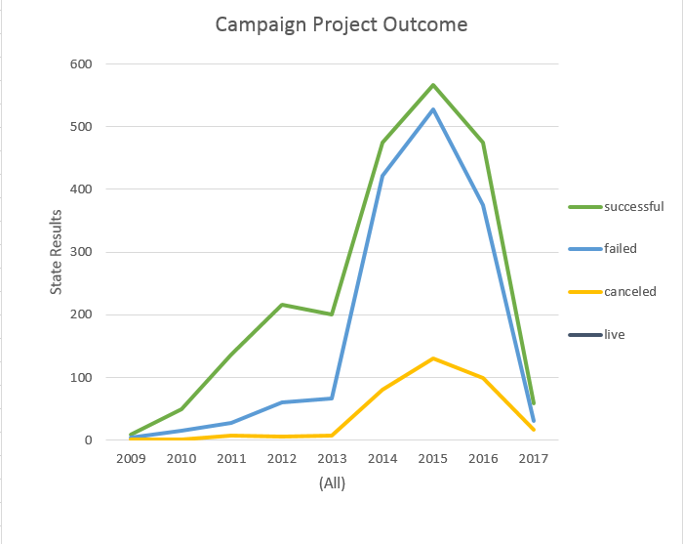

1. What are some limitations of this dataset?

* The size of the sampling dataset (4114) is only 1% of the total projects (300k+) therefore it might not be as accurate to determine or predict any types of trends.
* Goal amounts are in different currencies so you have to convert all currencies into one in order to accurately make any predictions or trends.

1. What are some other possible tables/graph that we would create?

* We can create a scatter and use a trend line to find a relationship between the two variables
* We can also run the regression analysis to determine the coefficients between each independent variable and dependent variable.